1. What is Helm Chart?
2. Why we need Kubernetes?
3. How Helm chart will help us to manage K8s?
4. How to install Helm chart?

**What is Helm Chart?**

A **Helm Chart** is a collection of files that describe a set of Kubernetes resources. Helm is a package manager for Kubernetes, and a Helm Chart is the packaging format it uses. Helm Charts simplify the deployment, scaling, and management of applications in a Kubernetes cluster by allowing you to define, version, and share Kubernetes application configurations in a standardized way.

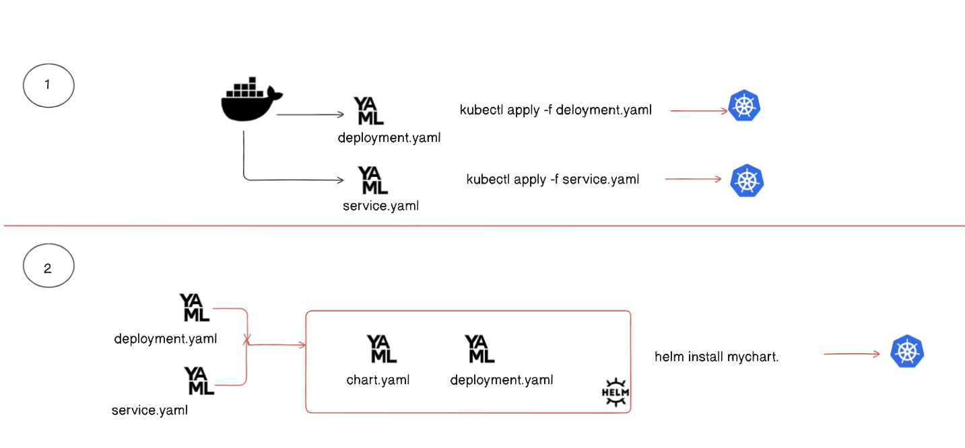

**Why we need Kubernetes?**

1. **Scalability** - You cannot scale single container to server millions of request.
2. **Automate Docker Deployment** - k8s can he manage automate the docker deployment.
3. **Auto-Healing -** If a container is not healthy then k8s can auto replace the container.
4. **Rollout & Rollback** - k8s monitors the unhealthy docker container and restart unresponsive.

A **rollout** is the process of deploying a new version of an application or workload to the Kubernetes cluster. It typically involves updating the containers running in Pods to a newer version.

A **rollback** reverts the Deployment to a previous version if a rollout fails or introduces issues. Kubernetes stores the history of Deployment revisions, allowing you to switch back to an earlier, stable.

**How Helm chart will help us to manage K8s?**

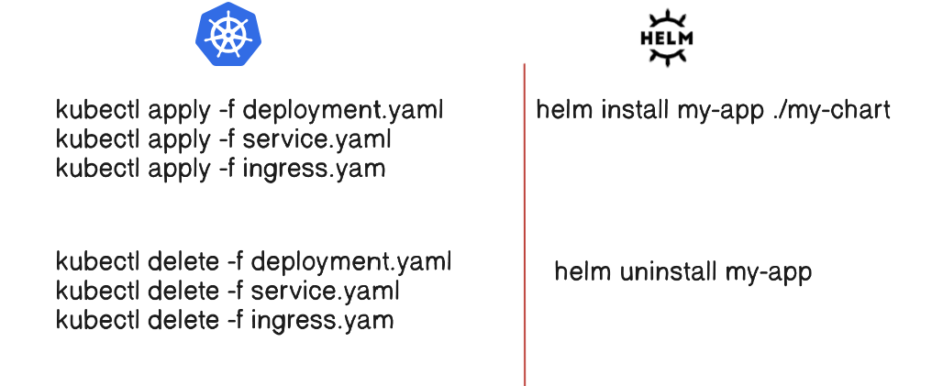

**Installing Helm Chart with Pre-requisites**

**Pre-requisites**

1. **One running Kubernetes cluster**:  
   You need any of the following:
   * **EKS**: Amazon Elastic Kubernetes Service
   * **GKE**: Google Kubernetes Engine
   * **AKS**: Azure Kubernetes Service
   * **microk8s**: Lightweight Kubernetes for local development (used for this demo).

Microk8s installing in ubuntu through microk8s documentation

<https://microk8s.io/docs/getting-started>

sudo apt update -y

sudo snap install microk8s --classic --channel=1.31

**Join the group**  
sudo usermod -a -G microk8s $USER

mkdir -p ~/.kube  
chmod 0700 ~/.kube

newgrp microk8s

or

su - $USER

microk8s config > ~/.kube/config

sudo chown -R vmvignan ~/.kube

ls -l ~/.kube/config

sudo microk8s status --wait-ready

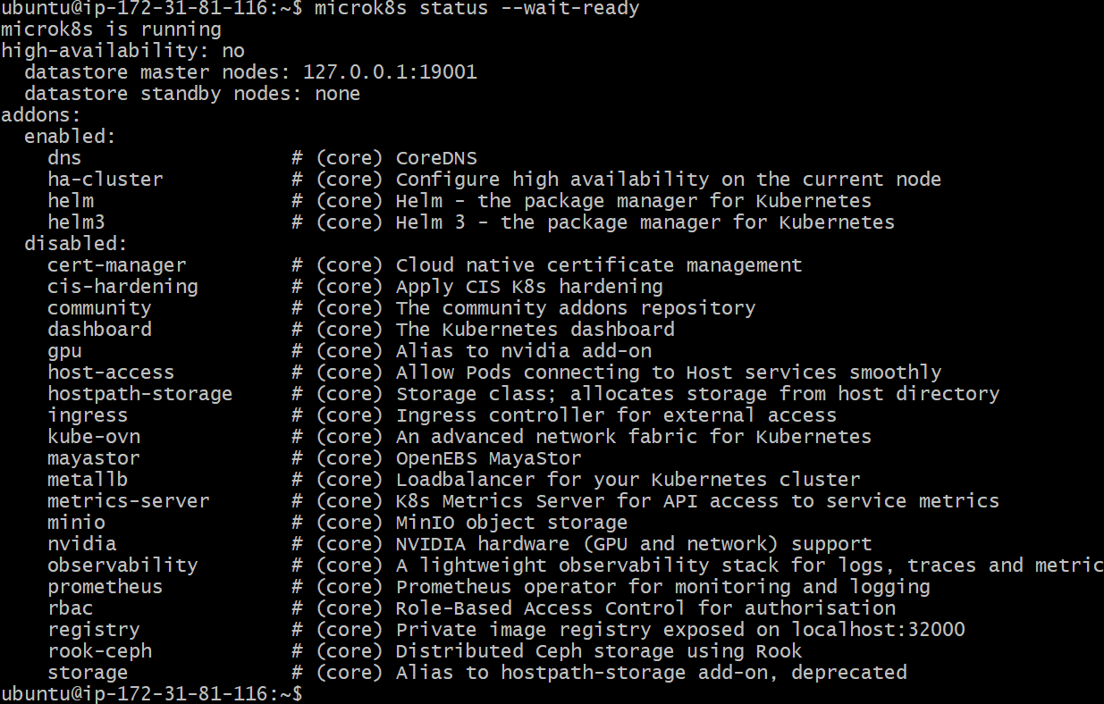

**Install kubectl**

**sudo snap install kubectl --classic**

**or**

**follow document**

[**https://kubernetes.io/docs/tasks/tools/install-kubectl-linux/#install-kubectl-binary-with-curl-on-linux**](https://kubernetes.io/docs/tasks/tools/install-kubectl-linux/#install-kubectl-binary-with-curl-on-linux)

microk8s kubectl get services

alias kubectl='microk8s kubectl'

kubectl get all --all-namespaces

**install HELM in ubuntu**

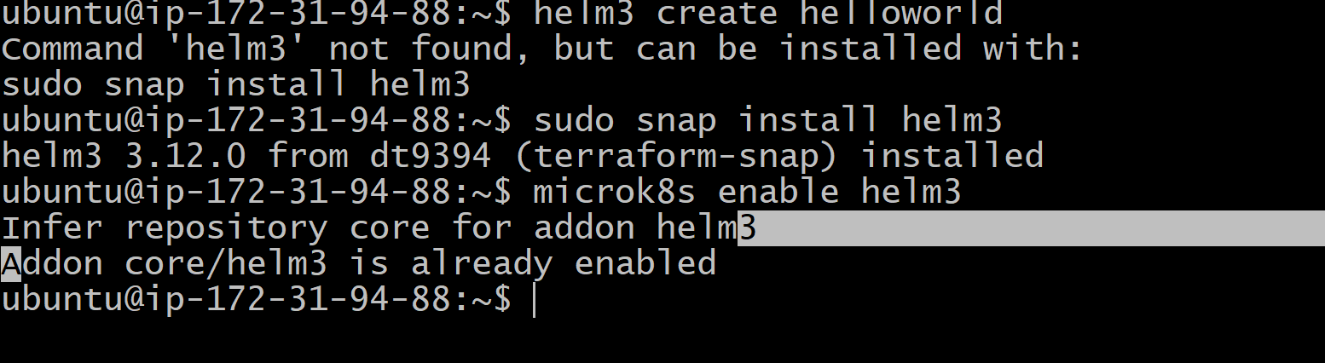

Run the following scripts -

curl -fsSL -o get_helm.sh https://raw.githubusercontent.com/helm/helm/master/scripts/get-helm-3

*bash*

chmod 700 get_helm.sh

*bash*

1./get_helm.sh